**My GitHub repository:**

**My presentation and demo video:**

[**https://youtu.be/m0mABHdf-Pc**](https://youtu.be/m0mABHdf-Pc)

**Screenshots of my app:**

**Main page: I will use Judson to login**

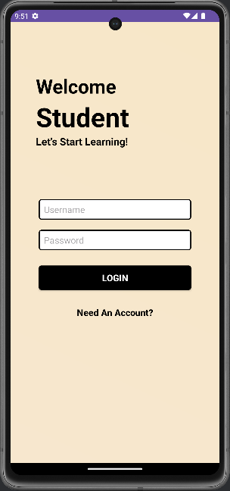

**Registration page:**

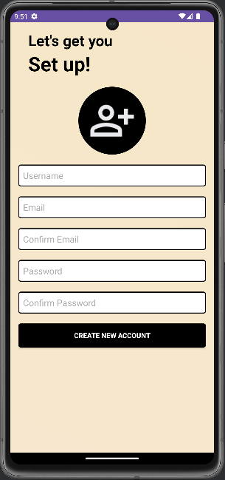

**Content page: each button represents a learning tool**

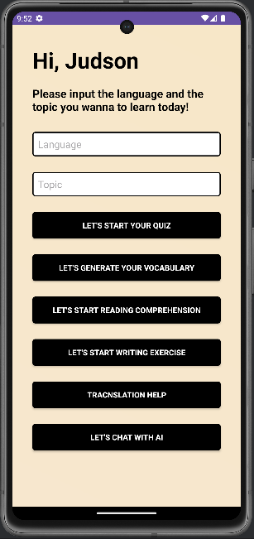

**Quiz page: The language is Chinese and the topic is Environment**

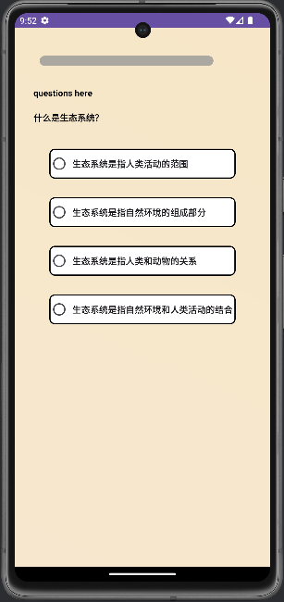

**Quiz result page:**

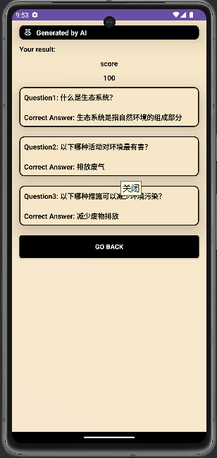

**Vocabulary generation page: The language is Chinese and the topic is Environment**

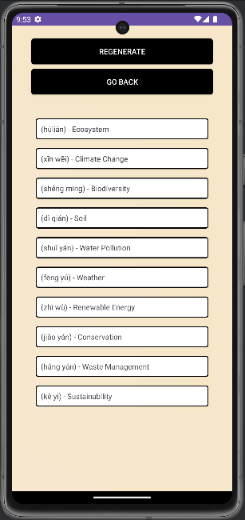

**Reading comprehension task page: The language is Chinese and the topic is Environment**

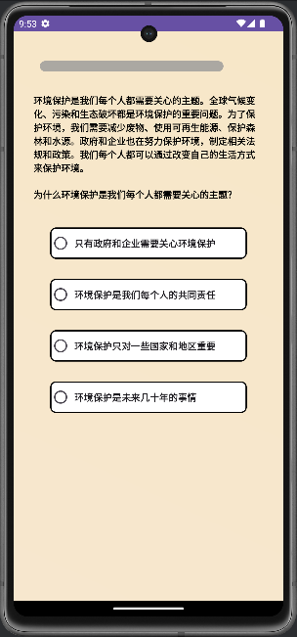

**Reading comprehension result page:**

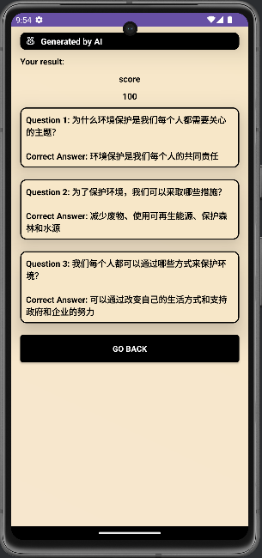

**Writing task page: The language is Chinese and the topic is Environment**

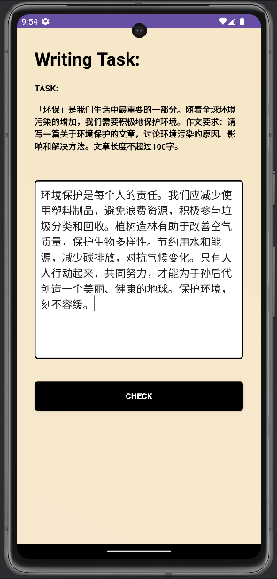

**Writing comment page:**

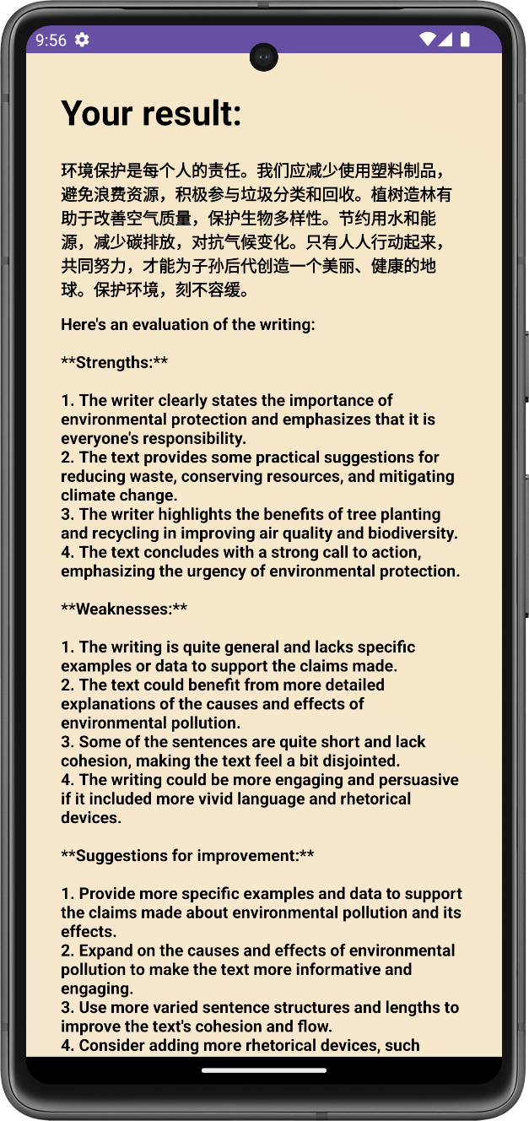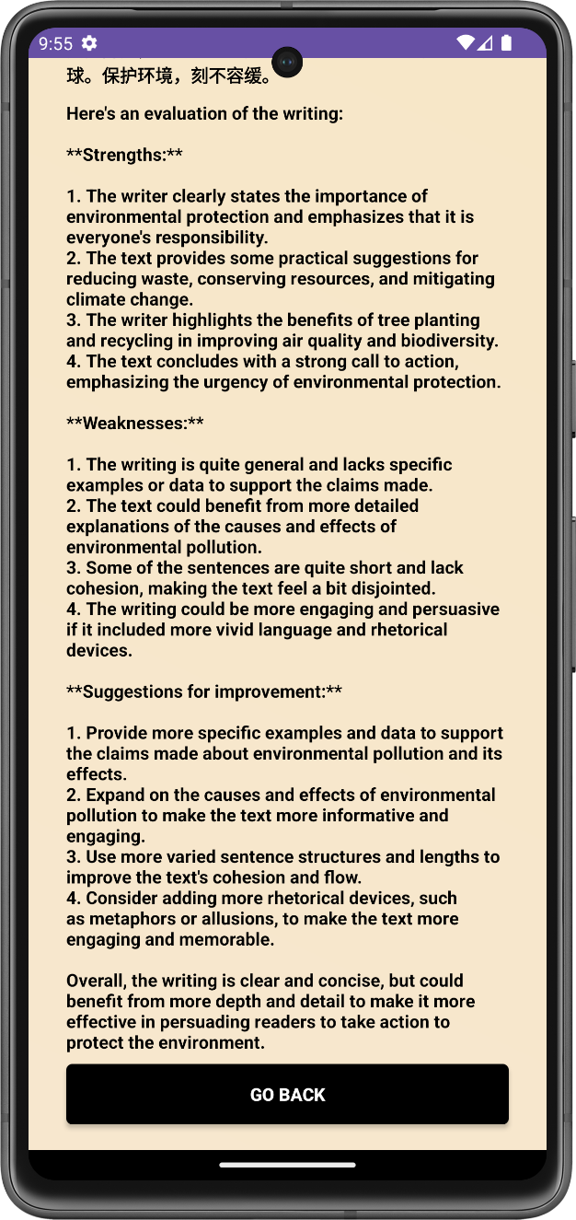

**Translation help page: text: hello, original language: English, target language: German**

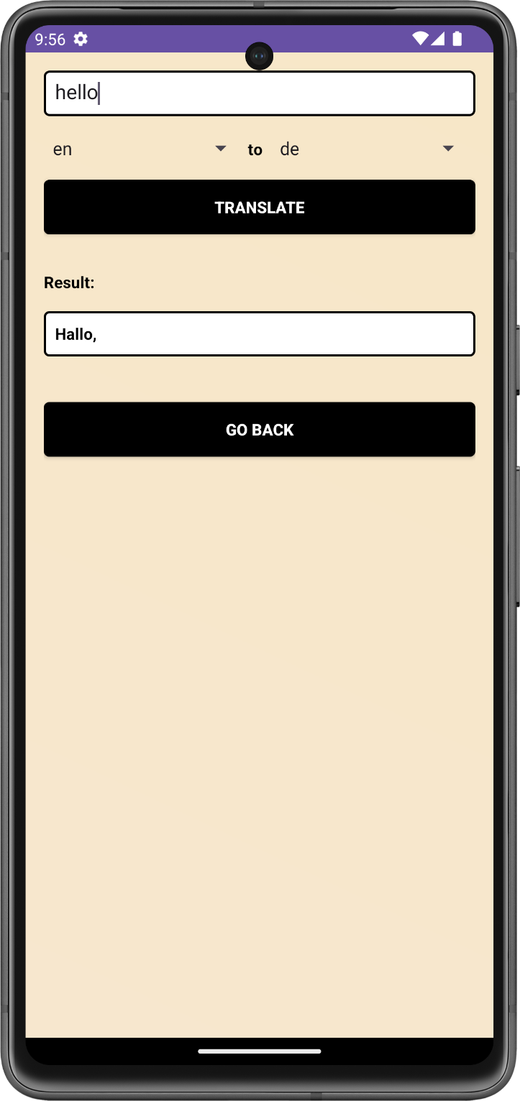

**AI chatbot page: 你好 means hello.**

